Appendix 1

Database of Unsafe and Non-Compliant Products
Detected on the CEFTA Market

Vision, Objectives, Benefits and Technical Specification

ABBREVIATIONS

AP5 | Additional Protocol 5
CEFTA | Central European Free Trade Agreement
EC | European Commission
EPREL | EU Product Register for Energy Labelling
EU | European Union
ICSMS | Information and Communication System for Market Surveillance
MS | Market Surveillance
RAPEX | Rapid Exchange of Information System
SME | Small and Medium sized Enterprises
VPN | Virtual Private Network
WS | Web Services
WSDL | Web Services Definition Language
XML | Extensible Mark-up Language

Contents

1 Introduction 4
2 The vision 4
2.1 The database 4
2.2 The information in the database 5
2.3 Access 5
2.4 Workflow – how the database is used 6
2.5 Interfaces 6
2.6 Data security 6
2.7 Implementation 7
3 Benefits of a database 7
4 Technical specification for the envisaged CEFTA MS database 8
4.1 Implementation recommendations 8
4.2 Structure of the CEFTA MS database 10
4.3 Functionalities of the CEFTA MS database 11
4.4 Data structure 16
Annex 1 - EU IT systems with similar features 24
The EU Safety Gate (formerly known as RAPEX) 24
ICSMS 24
EPREL 25
Annex 2 – Technical note on MS database workflows 26
Annex 3 – Overview of survey results 28
Annex 4 – Questions and answers regarding the CEFTA database 29

Introduction
This document presents a vision for creation of a common CEFTA database of unsafe and non-compliant products as well as a list of objectives and benefits that such a database can be anticipated to bring about once it has been implemented.
The database is being considered in the context of the Additional Protocol 5 and Annex 1 that provide legal base for creation of a database to help prevent the distribution and placing of unsafe products on the CEFTA market. It should in particular target:
- Products that do not comply with the applicable technical regulations.
- Products that comply with the technical regulations, but still endanger public interests or life and health of people, animals or plants.
- Products that are illegal to import.
The document has four annexes. Annex 1 gives a very brief description of three EU IT systems that have a lot of features in common with the envisaged CEFTA Market Surveillance (MS) Database. Annex 2 provides technical note on proposed CEFTA MS Database workflows. Annex 3 provides an overview of survey results specifically existing IT solutions and scope of the future system, and Annex 4 contains a number of question and answers that were brought up in connection with the two online “Exploratory Talks Meetings”.

The vision

The database
The vision is to establish one common database that will enable authorities that work with product safety in the CEFTA Parties to cooperate on preventing unsafe or non-compliant products from entering the market and ending up in the hands of the consumers.
The database should store information about products that have been investigated or are under investigation by one of the CEFTA Parties, in particular:
- Products that do not comply with the applicable technical regulations.
- Products that comply with the technical regulations, but still endanger public interests or life and health of people, animals or plants.
- Products that are illegal to import.
The purpose is to facilitate sharing of knowledge and experiences between authorities working with product safety and compliance in the CEFTA Parties.
The database should be able to handle any kind of non-compliant products, not only unsafe products, but also products that fail to meet the energy labelling rules, products that don’t comply with the rules for emitting electromagnetic noise, non-compliant measuring equipment to mention a few examples.

The information in the database
The database shall store all information that the authorities gain access to during a product investigation including:
- Detailed identification of the product, e.g. bar codes, serial numbers, batch numbers, photographs, etc.
- Details on the actors in the supply chain, e.g. manufacturer, importer, distributors, etc.
- Evidence from investigations such as technical documentation, reports from test laboratories, reports from document inspections, etc.
- Contact details for the authority who has undertaken the investigations.
Some of the proposed modules are:
- Manual data entry for products
- Data import /export for products
- Publishing information on products - including search
- Notifications on product publishing for subscribers (could be part of the module 3)
- Data entry and upload of additional relevant documents
- Publication of additional relevant documents - including search
- User interface for products search and cases matching
- Administration of the database

The system may also be used for storing and exchanging other kinds of information relevant for market surveillance such as documents from Joint Actions undertaken by the CEFTA Parties, reports from market surveillance actions or annual reports.
The database may have several cases on the same product if it has been investigated by several different CEFTA Parties or at different points in time. It must be possible to access all such cases as they can contain valuable information for new investigations.

Access
All CEFTA Parties should be able to enter information about a product or a case. All CEFTA Parties should be able to access the information in accordance to the agreed access rights.
Market surveillance authorities, agencies and inspectorates will have full access to the database as they will use the data in their work to inform planning or decision-making and to identify products banned by other CEFTA Parties for follow-up actions. Moreover, they can extract knowledge about how cases have been executed or which non-compliances have been found with certain products.
Customs authorities should have access to a certain subset of the information in the database that concerns identification of products as they will need this information to identify blocked or banned products and prevent them from entering the CEFTA market. This will be defined once an overview of the full contents of the database has been established.
Furthermore, the database should have a public part where consumers and businesses can see public information about unsafe products. This will be defined when the overview of the contents of the database has been established.

Workflow – how the database is used
The authorities are envisaged to upload information to the CEFTA database as a case evolves. This is shown in the below table for a generic market surveillance case.
Step in market surveillance process | Data to upload
Identify and sample product | Model name, brand name, type number, bar codes, serial number, technical product data (voltage, current, power, etc.).
Examination of technical documentation, preliminary technical inspection of product (“desktop testing”) | Documents that have been acquired.  Results and observations from investigations. Inspection reports generated during the examination.
Laboratory testing of product | Test report.  Results and conclusions.
Risk assessment | Risk assessment report.
Enforcement, follow-up | Information gained during consultation with the economic operator.  Measure agreed.  Information about supply chain.  Results, observations and lessons learned from implementation of measure.

This table suggests that the information is generated in distinct steps. This is generally speaking the case, but information can turn up at any stage during the process and it must be possible to add or correct information whenever it is captured. Data will be accessible for all users of the database (subject to their access rights) as soon as they have been uploaded.

Interfaces
The database should interface to existing Market Surveillance Information Systems in the CEFTA Parties so that data once entered somewhere doesn’t have to be retyped.
The interface would mostly be one-way from the Parties system to the CEFTA database. However, it can be useful to be able to download certain information from the CEFTA database, in particular if it features functionality like described above allowing laboratories or economic operators to input information.

Data security
Data in the database should be firmly secured to avoid that unauthorised people can access the information. This is essential as most of the information can be expected to be commercially sensitive and therefore confidential.
This clearly requires an appropriate security system with passwords, two-factor authorisation or other appropriate means, but it also requires strict procedures in all CEFTA Parties to administer access rights when employees change jobs or leave the authority. The security level has to reflect professional secrecy and personal data protection and to be harmonised across all CEFTA Parties.

Implementation
Experiences from the EU ICSMS system is that such a database can be a very complex and large so it must be carefully considered how to break it up in modules that can be implemented one by one.
This approach also has the advantage that it is possible first to focus on the modules that will be easiest to implement with the highest chances for success and it is possible to add new modules later when the demand occurs (for instance when new legislation regulating a new product group enters into force).
Data cleaning is also an important element in the implementation. It is important to remove spurious or erroneous data and to harmonise the registration of data. A lot of this work has to be done in the Parties systems before data are transferred to the CEFTA database first time, but some can only be done afterwards when data have been uploaded. This is particularly the case for the linking of different cases concerning the same products. All CEFTA Parties have undertaken market surveillance activities for many years so there will be cases where authorities in different CEFTA Parties have investigated the same product. These cases must be linked to release the full benefit of the database. Some of this can be done automatically, but it is foreseeable that it also requires manual work to identify cases, correct data and link them correctly together.

Benefits of a database
As touched upon in the previous chapter, such a database of unsafe or non-compliant products would bring about a number of benefits for the CEFTA Parties. These include the following:
- It will be possible to utilise all the experience gained in the CEFTA Parties regarding market surveillance procedures and unsafe or non-compliant products to further increase the efficiency in the market surveillance process, develop new market surveillance procedures and design and target future market surveillance campaigns.
- It will be possible for the business community to learn from other manufacturers’ mistakes and experiences so they avoid importing products that have already been banned elsewhere and repeating the errors of other producers so they manufacture unsafe products.
- All things equal, this database will increase the level of product safety in the market as it will be easier to identify unsafe products if that information is gathered from all CEFTA Parties and made publicly available.
- It will increase the harmonisation of the enforcement activities across the CEFTA Parties when all authorities can check in the database how other authorities have access similar non-compliances. This in turn will decrease the economic operator’s incentive to “shop around” claiming that “other authorities look differently at this” because all authorities will have access to the full information about the case.
- It will be easier for customs to prevent unsafe products from entering the entire CEFTA market as they only have to check in one system to identify unsafe, non-compliant or prohibited products. At the same time, this work will be more efficient as the decision to block or not can be based on reports from any one of the CEFTA Parties.
- It will be easier for consumers and businesses to look up information about unsafe products when they only have to check one website for products from anywhere in CEFTA.
- It will put more pressure on the economic operators when they know that an error will have far-fetching consequences as the information will be disseminated in all CEFTA Parties.

Technical specification for the envisaged CEFTA MS database

Implementation recommendations
The CEFTA MS database technical specification is based on the following objectives that should be considered for such a database holding information on unsafe and non-compliant products. The recommendations are based on experience from the EU databases.
Recommendations:
- The database is trustworthy and reliable
It is absolutely essential for the success of the database that the credibility of the database is never questioned and that it is perceived as a trustworthy and reliable source of information.
This implies that all data that are supposed to be in the database must be there and all information in the database must be correct. It will undermine the user’s faith in the database if others are able to come up with more data or in other ways show that the database presents wrong or incomplete information.
No database can present everything about everything so this is much about scoping and defining the boundaries of the database and its information as clearly as possible.
- Data in the system are secure
It is foreseeable that the database will contain information that is commercially sensitive such as details about the design and construction of products, sales and distribution channels, etc. This information is essential for other market surveillance authorities so it should be shared, but it can damage or even injure a business if the information is released to competitors.
Thus, the access to confidential information must be carefully guarded so that only market surveillance authorities can access it in accordance to the agreed access rights. If it becomes known that it is possible to access sensitive information, it will impact on the businesses’ willingness to supply the information which in the longer run will compromise the credibility of the database.
- The database is well known to all users
The database can be envisaged to get many different user categories with different needs:
- Market surveillance authorities that will look for information about similar cases to benefit from previous experiences.
- Customs that will check if the imports of certain products have been banned by one or more CEFTA Parties.
- Consumers that will check if products are unsafe so they should avoid purchasing them.
- The business community that may be looking for information about unsafe products to benefit from the information in their own manufacturing or to avoid importing illegal and unsafe products.
It is important for the pick-up of the database that all users are aware of its existence and what they can use it for.
- It is possible to uniquely identify products
It is important that users who have found a product in the database are able to determine whether a physical product is identical to the one from the database.
To do so the user should be able to obtain a number of unique product identifiers. These would normally be name of manufacturer, model name and type number, but they might also include batch numbers, serial numbers or other characteristics that will enable an identification of a smaller subgroup of products if only some items (e.g. a certain batch, certain serial numbers, etc.) are unsafe.
Clear colour photographs of the product, the marking plate and the packaging are generally considered to be necessary identifiers.
- Users benefit from other cases
The database can be seen as a big collective archive of mistakes and lessons learned. Whenever somebody manufactures an unsafe product, then the information ends up in the database so others can learn from it and avoid making the same mistakes. Similarly, every time a market surveillance authority uploads a case, it includes a lot of knowledge about how the case was run, what went well and probably also what went less well.
Therefore, it is an important objective that society (first and foremost the business community and the market surveillance authorities) will utilise the information to improve their own performance and avoid repeating the same mistakes.
- The database is easy to use for all its users
All user categories must experience that it is easy to access the database and the information inside it or they will soon stop using it.
Therefore, it is important to consider how users will access and use the database. The EU databases are accessible via a browser on a PC, but is this user-friendly if you are a consumer in a shop and you want to check a product on your smartphone before you buy it?
Of course, there is a trade-off here and the solution should provide several user interfaces – one for mobile access for consumers, another for expert’s uploading of data, etc.
- It is possible to extract statistics from the database
To increase the value of the database as “the archive of mistakes, lessons learned and good experiences” it should be possible to extract different kinds of statistics from the database for further analysis. This could provide intelligence to help shape future market surveillance actions or it could input to authorities’ development of internal procedures, but it could also be statistics for annual reporting to ministries or the general public, and any further applications.
The easiest way to enable such analyses is to have a user-friendly interface through which data can be transferred to an appropriate tool, e.g. MS Excel or SAS.
- The involved organisations feel a strong ownership of the database
One of the weak points of many projects is that they focus on the development of the tool but forget the subsequent operation and maintenance. The best way to prevent this is to have a clear sense of ownership among the recipients of the tool so they want to maintain the tool after the project has ended.
- The CEFTA MS database interfaces to internal market surveillance information systems
The information in the CEFTA MS database will presumably to a large extent be uploaded by the market surveillance authorities in the CEFTA Parties so you can expect that most of (if not, all) this information will already have been entered in these organisations’ market surveillance information systems.
To avoid that the same data has to be entered manually in several different systems, the CEFTA MS database must interface with the internal systems so that data can be transferred and updated automatically from local systems or wizard like import of the structured data (MS Excel format or comma separated text) should be supported.
This will also eliminate an error source if data are copied electronically or imported in a controlled wizard like procedure, from one system to the other, instead of being typed in again.

Structure of the CEFTA MS database

CEFTA MS database has an internal and a public area:
• The internal area is only accessible to market surveillance authorities and customs authorities of the CEFTA economies.
• The public area is available for consumers, users and manufacturers. The information in this area provides only a description of the product and a summary of its non-compliance.

Functionalities of the CEFTA MS database

The system allows quick and efficient sharing information on non-compliant products between authorities:
- test results,
- product identification data,
- economic operator information,
- accident information,
- information on measures taken by surveillance authorities, etc.,

It should support market surveillance activities, by providing a register for their documentation, the identification of the products inspected and the results of the tests/checks.

The CEFTA MS database user interface should enable specific users to search for:
- Non-compliant products.
- Administrative bodies
- Publicly accessible market surveillance activity documents

Search UI should enable using several search criteria.

Example screens are presented in the following figures.

Screen #1 /Insert new unsafe item/ 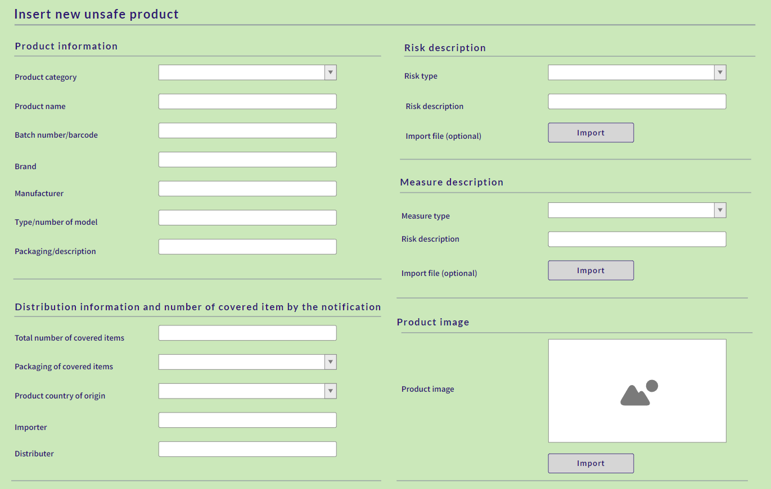

Screen #2 /Search for unsafe products/
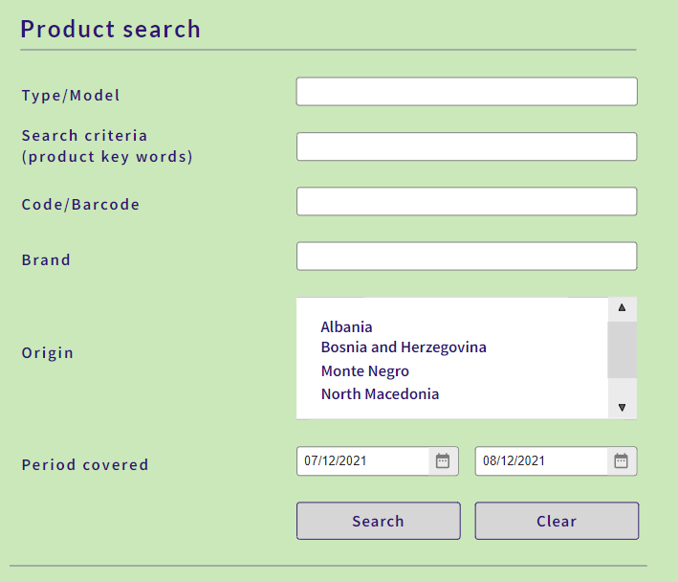

Screen #3 /Search for MS document/
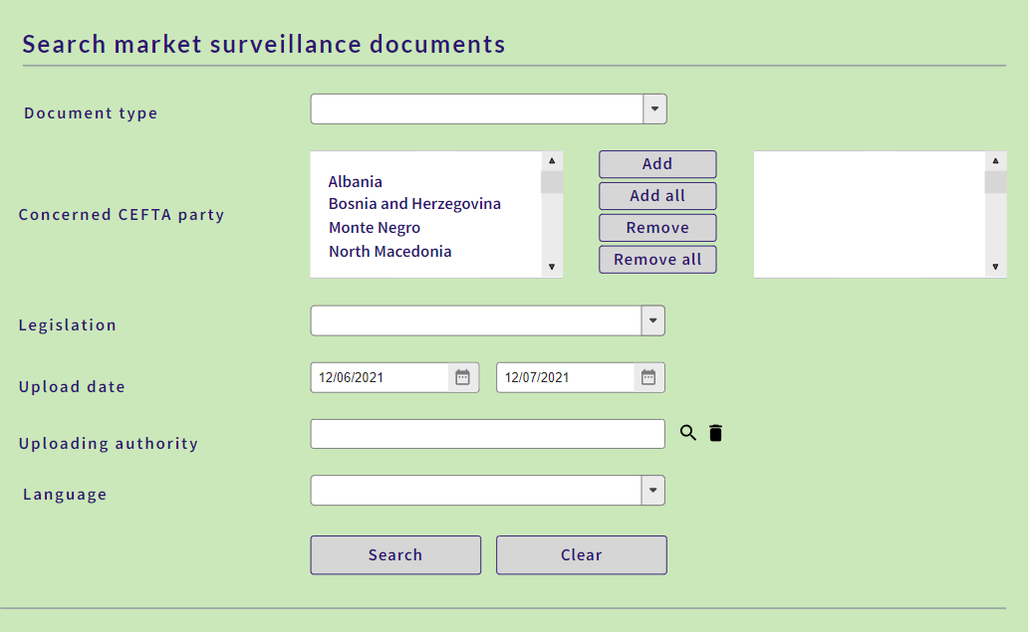

Screen #4 /Search for MS authority/

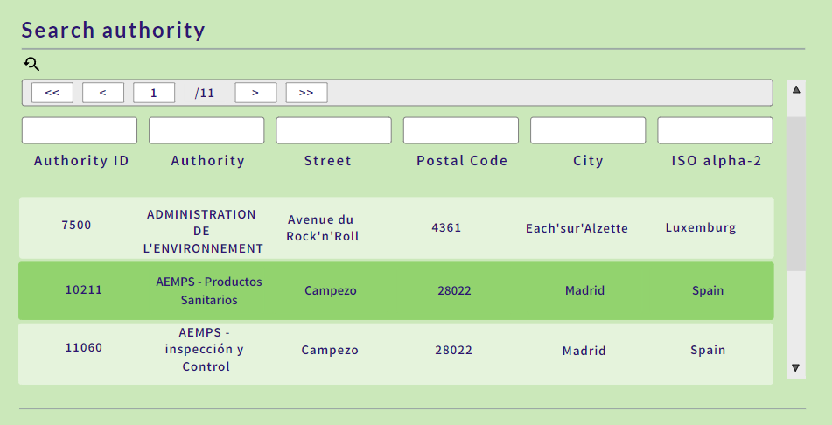

Data structure
Data model capturing relevant information about the non-compliant product and corresponding risks and the measures taken follows:
 | Field Name | Field type | Description
1 | ID | N | Unique identifier of a record (Primary KEY).
2 | CreatedDate | D | System date and time of creation of a record in the database.
3 | CreatedBy | AN | Username person who has created a record in the database.
4 | CreatedByID | N | ISO alpha-2 of the affiliation for the person who created the record in the database.
5 | Flag | AN | Flag Code. Selection from a list of flag codes (See table Specific codes: FLAG_CODES).
6 | AlertID | N | Alert code. Selection from a list of alert codes (See table Specific codes: ALERT_TYPES).
7 | ProductCategoryID | N | Product category code. Selection from a list of product category codes (See table Specific codes: PRODUCT_CATEGORIES).
8 | ProductName | AN | Full product name.
9 | ProductImage | LOB | Product picture.
10 | BarCode | AN | Product barcode.
11 | Brand | AN | Full product brands name.
12 | ProductType | AN | Type / number of model
13 | TotalNumCaveredItem | AN | Total number of items covered by the notification.
14 | ProductPackaging | N | Total number of items covered by the notification.
15 | Unit | N | Unit codes. Selection from a list of unit codes.
16 | MeasureTypeID | N | Measure type codes (See table Specific codes: MEASURE_TYPES).
17 | MeasureDescription | AN | Details of measure.
18 | MesureFile | LOB | Category of measure. Max file size limit 100 MB.
19 | ProductOrigin | N | ISO alpha-2 code of product origin.
20 | ProductProvenance | AN | The provenance of the product.
21 | Manufacturer | AN | Details information of the manufacturer(s).
22 | Importer | AN | Details information of the importer(s).
23 | Distributer | AN | Details information of the distributor(s).
24 | Exporter | AN | Details information of the exporter(s).
25 | Retailer | AN | Details information of the retailer(s).
26 | LegalProvision | AN | Legal provisions (directive, decision, regulation)
27 | Standards | AN | Standards
28 | Conformity | AN | Proof of conformity (including existence of marks, i.e. CE marking etc.)
29 | Certificate | LOB | Appropriate valid certificate. Max file size limit 100 Mb.
30 | ProductCounterfeit | AN | Is the product counterfeit? (YES or NO).
31 | RiskTypeID | N | Risk type code. Risk type code. This field describes the type of risk during the using products for human life or the environment (See table Specific codes: RISK_TYPES).
32 | RiskDescription | AN | A complete description of the hazards caused by the product in case of its use.
33 | RiskFile | LOB | File with additional description of product and hazards that its cause.
34 | LegalProvision | AN | Legal provisions (directive, decision, regulation)
35 | RiskConclusion | AN | Risk assessment and conclusions.
36 | RiskConclusionFile | LOB | Risk assessment and conclusions. Max file size limit 100MB.
37 | Notification | AN | Notification sent by a producer or a distributor.

List of specific codes:
FLAG_CODES
FLAG_CODES
ID | Name
CONF | Confidential
NOCONF | Not confidential

PRODUCT_CATEGORIES
PRODUCT_CATEGORIES
ID | Name | Note
1 | Chemical products
2 | Childcare articles and children's equipment
3 | Clothing, textiles and fashion items
4 | Communication and media equipment
5 | Construction products
6 | Cosmetics
7 | Decorative articles
8 | Electrical appliances and equipment | Electrical devices
9 | Explosive atmospheres equipment
10 | Food-imitating products
11 | Furniture
12 | Gadgets
13 | Gas appliances and components
14 | Hand tools
15 | Hobby/sports equipment
16 | Jewellery
17 | Kitchen/cooking accessories
18 | Laser pointers
19 | Lifts
20 | Lighters
21 | Lighting chains
22 | Lighting equipment
23 | Machinery
24 | Measuring instruments
25 | Motor vehicles
26 | Pressure equipment/vessels
27 | Protective equipment
28 | Pyrotechnic articles
29 | Rail and guided transport
30 | Recreational crafts
31 | Stationery
32 | Toys
33 | Waste
34 | Other

RISK_TYPES
RISK_TYPES
ID | Name | Note
1 | Asphyxiation
2 | Burns
3 | Chemical
4 | Choking
5 | Cuts
6 | Damage to hearing
7 | Damage to sight
8 | Drowning
9 | Electric shock
10 | Electromagnetic disturbance
11 | Energy consumption
12 | Entrapment
13 | Environment
14 | Fire
15 | Health risk / other
16 | Injuries
17 | Incorrect measurement
18 | Microbiological
19 | Security
20 | Strangulation
21 | Suffocation
22 | Other

MEASURE_CATEGORY
MEASURE_CATEGORY
ID | Name
1 | Ban on the marketing of a product
2 | Destruction of a product
3 | Import rejected at border
4 | Making the marketing of a product subject to prior conditions
5 | Marking a product with appropriate warnings on the risks
6 | Other
7 | Recall of a product from end users
8 | Temporary ban on the supply, offer to supply and display of a product
9 | Warning consumers of the risks
10 | Withdrawal of a product from the market

MEASURE_TYPES
MEASURE_TYPES
ID | Name
1 | Voluntary measures
2 | Compulsory measures
3 | Unknown

UNIT_CODES
UNIT_CODES
ID | Name
1 | Box
2 | Kilogram
3 | Litre
4 | Meter
5 | Pieces
6 | Unit

The data set to be published corresponds to the CEFTA notification form:
CEFTA NOTIFICATION FORM
Notifying economy
1. Notifying parties
2. Date sent
3. Details of notifying authority
PRODUCT IDENTIFICATION

4. Product category (select)
5. Product name
6. Brand
7. Type / number of model
8. Batch number / bar code
9. Customs code (search)
10. Product and packaging description
11. Total number of items covered by the notification (enter count and select unit)
12. Photos of product, packaging and label
REGULATIONS AND STANDARDS APPLICABLE
13. Legal provisions (directive, decision, regulation)
14. Standards
15. Proof of conformity (including existence of marks i.e. CE marking etc) Attach certificates (max size limit 2Mb per attachment)
16. Is the product counterfeit? (select)
TRACEABILITY
17. The provenance of the product
18. Origin of the product/Destination
19. Contact details of the manufacturer(s) (leave blank if unknown)
20. Contact details of the exporter(s) (leave blank if unknown)
21. Contact details of the importer(s) (leave blank if unknown)
22. Contact details of the distributor(s) (leave blank if unknown)
23. Contact details of the retailer(s) (leave blank if unknown)

RISK DESCRIPTION
24. Risk category (select)
[other risk category]
25. Summary of test results (brief description of technical defects) Attach test report (max. size 2Mb per attachment)
26. Legal provisions and standards (with clauses) against which the product was tested and did not comply
27. Risk assessment and conclusions. Attach copy (max. size 2Mb per attachment)
MEASURES
28. Type of measures (select)
29. Authority/economic operator taking notified measures
30a. Category of measure (Attach measure (max. size 2Mb per attach)
30b. Other category of measure
31. Notification sent by a producer or a distributor under Article 5 (3) of GPSD

Annex 1 - EU IT systems with similar features
Three IT systems from the European Union seem to share some of the features of the envisaged CEFTA database so they will be briefly introduced here for background information. The three systems are the EU Safety Gate system, the EU ICSMS system and the EU EPREL system.

The EU Safety Gate (formerly known as RAPEX)
(Legal base: The General Product Safety Directive, 2001/95/EC, particularly article 11 and 12. Guidelines for the operation are laid down in the Commission Implementing Decision C(2018) 7334 as of 9 November 2018.)
The IT-side of the EU Safety Gate system (formerly referred to as the RAPEX system) is a database where EU market surveillance authorities report products that pose a (serious) risk to consumers. Products are notified when measures have been imposed or the economic operator has decided to take “voluntary” action.
The system operates with two categories of risky products – serious risk products that are notified via one procedure and “products presenting other risk levels” that are notified via another procedure. The most important difference is that other EU Member States are obliged to investigate cases with products presenting a serious risk to check if these products are found on their markets and afterwards report their results back to the European Commission according to a defined schedule.
The system has an open part where consumers and businesses can look up unsafe products. You can also subscribe to weekly overviews of notified products.

ICSMS
(Legal base: Regulation (EU) 2019/1020, particularly article 34.)
ICSMS is a database that is created to facilitate cooperation between EU market surveillance authorities. The authorities will upload all information about their cases as they evolve and more information is generated. The idea is that other market surveillance authorities in other Member States can avoid working on the same products (without knowing).
The system includes functionalities for “passing the baton”, i.e. transferring cases from one authority to another. This is useful if Member State A investigates a product that is manufactured in Member State B. In that case, the authorities may agree that it is more efficient that the case is handled by Member State B and ICSMS facilitates the easy transfer of the case. Moreover, ICSMS interfaces to other IT systems, first and foremost the EU Safety Gate system (RAPEX). Thus, it is possible to create Safety Gate notifications automatically.
The downside is that the system contains so much information that many authorities consider it to be cumbersome to work with the system and upload the information. Moreover, the security governing the central parts of ICSMS is extremely high (and has to be) as the database contains a lot of commercially sensitive information (detailed technical files for products, etc.).
ICSMS has a public part where consumers can search for information about products in the database.

EPREL
(Legal base: Regulation (EU) 2017/1369, particularly article 12.)
EPREL is a database for products with energy labels. Economic operators are obliged to upload the technical documentation for their product to the database before products can be placed on the market.
Market surveillance authorities can access and check the documents in the database. This implies that it is possible for the authorities to run document inspections without involving the economic operators. Market surveillance authorities are also able to enter results of their investigations in the database so other authorities can benefit from this knowledge in their own work. Work on an interface to ICSMS is on-going.
EPREL has a public part where consumers can search for energy labels and datasheets for products in the database.

Annex 2 – Technical note on MS database workflows

Note: Two-scenario workflows for users and datasets with and without CEFTA Party's database

 | The CEFTA database only contains information about products | The CEFTA database contains information about products plus case management information
CEFTA Party has own electronic case management system | Inspector records data in Party's case management system.  Subset of data are automatically transferred to CEFTA database. | Inspector records data in Party's case management system.  Complete dataset is automatically transferred to CEFTA database.
CEFTA Party has no database and no electronic case management system | Inspector records data on paper for the Party's paper file  Inspector or dedicated staff enters subset of data in CEFTA database | Inspector records data.  Records can be kept on paper. Then the inspector or dedicated staff transfers data to the CEFTA database.  Or the inspector may work directly in the CEFTA database.

- The upper row (CEFTA party has own case management system) represents situations where the impact on the CEFTA party is very small. The inspectors work the way they have always done and the interface to the CEFTA database is handled automatically. This is the preferred scenario. If the transfer cannot be handled automatically, it might be possible to run it "quasi-automatically" where dedicated staff will upload the data, having actually web-service (WS) based interface on the side of the CEFTA MS Database and development of the software component “MS Product Wrapper” at the CEFTA Party side responsible to pack the dataset and submit it to the CEFTA MS Database using the WS interface.

- The lower row (no own case management system) may require some changes in the organisation of the market surveillance at the affected Parties.
If the CEFTA system only holds data on products, then the Party has to establish routines for extracting that information from the paper files and entering it to the CEFTA database. in practice it seems that the easiest way to do this is by leaving the task to the inspector.
If the CEFTA system contains all information about the case (including letters to and from the economic operator), the CEFTA party will find itself in one of two situations:
- Either they establish procedures for a manual upload of all data from their paper files.
- Or they may decide to use the CEFTA database as their electronic case management system. This option will require extra development work to produce a user interface that is suited for that use.
The CEFTA MS database should provide user interface for manual data entry for the data sets defined for product (and case outcome) description. In case the data are existing in electronic form as MS Excel spreadsheet manual entering could be avoided by using again “MS Product Wrapper” to upload the pack the data and submit it to using the WS interface.

Annex 3 – Overview of survey results

Existing IT solutions

Question | ALB | BIH | MDA | MNE | SRB | XKX*
A1 MS IT system implemented | The database for SIMS | MSA database | No | CISCP (Central Information System for Consumer Protection) | NEPRO | Rapex Kosovo
A2 Option for data exchange provided | n.a. | No | No | Yes | Yes | Yes
A3 Data format | n.a. | Structured | No | Structured | Structured | Structured

Scope of the future system

Question | ALB | BIH | MDA | MNE | SRB | XKX*
B1 Type of the workflow | Workflow | Workflow | n.a. | Notifications | Workflow | Workflow
B2 Type of cases | All inspected non-food products; non-compliant and compliant | All inspected non-food products; non-compliant and compliant | n.a. | Non-compliant and dangerous | All inspected non-food products; non-compliant and compliant | Non-compliant and dangerous
B3 Data to be exchanged | CEFTA Notification Form

Annex 4 – Questions and answers regarding the CEFTA database
The following question were brought up in connection with the two online “Exploratory Talks Meetings”. They are listed here together with answers for information.
Question: Would it cause problems if there are differences between the product safety legislation from one CEFTA Party to another?
Answer: No, everybody could still benefit from the database.
The EU Member States face the same challenges in their use of the Safety Gate and the ICSMS system. You often find that two Member States assess the same case very differently for good reasons. One example is differences in climatic conditions – in the northern part of Finland temperature may drop to below -20 degrees during winger while the temperature may go above +40 in Malta during summer. This could clearly cause difference in their assessment of the risk of a product. Differences in legislation could be another valid reason for assessing cases differently.
Still, it would be useful for everyone to know the assessments and the reasoning behind, as importers and manufacturers most certainly will complain that “your authority is much stricter than X-authority – that is not fair”. In that case, it is helpful to know the rationale behind “X-authority’s” reaction so you can explain to the economic operator why you assess the case differently.
Question: Is it possible to get an overview of ICSMS metadata?
Answer: Yes. The European Commission has published a user’s guide with an overview of the information that can be stored in the system.
Question: You mention that other sorts of documents could be stored in the CEFTA database. What sort of metadata should be collected for these documents?
Answer: Only data that would allow others to identify a specific document, i.e. the date, author and title of the document and potentially a short description of the context.
Question: How can we link different cases against the same product within the CEFTA database, but potentially also with the ICSMS system or the EU Safety Gate.
Answer: In ICSMS, different cases are linked via the product identifier. The person who enters data in ICSMS begins by searching for the product he is investigating. If he finds it, he puts the product identifier in his case.
The ICSMS guide recommends that the bar code of a product is always entered because it will provide the most certain identification of the product. If it is not available, it is possible to use model name, type name, pictures, etc. to identify the product.
Question: We need to explore further how and when it would be possible to exchange data between the EU systems (ICSMS, RAPEX) and the CEFTA database. We might want to ask the CEFTA Parties if and when they look up information in the EU systems. This will provide information about the need for interfacing to the systems.
Answer: Agree. This could be a sensible way forward.
Remark: Subsequent contacts to the European Commission have shown that it seems very unlikely that it would be possible to establish an automatic transfer of data between a CEFTA database and EU’s systems. When asked, the ICSMS team replied that they didn’t have any cases where data had been exchanged with non-EEA countries. The RAPEX team did not react to a similar request.
Question: Regarding the transfer of data from the existing local databases to the CEFTA database: Do we need a cut-off date or we transfer all the old files as well?
Answer: It seems sensible to have a cut-off so that only information that is less than 5 years old is transferred. Most products that were on sale 5 years ago would have been discontinued by the manufacturer in the meantime.
Question: Is it possible to do away with the CEFTA database and skip the local databases once data have been transferred initial data transfer? What are the pros and cons?
Answer: Yes, you could imagine that a CEFTA database could take over the role of the local databases.
The biggest advantage of doing so is that there will only be one database to maintain and the need for interfaces and data transfer between the CEFTA database a number of local databases will disappear.
However, such a solution would also bring about significant disadvantages. The main purpose of the local databases is most likely to support the Party’s administration of market surveillance cases. So it will help the market surveillance authority communicate correctly with economic operators, follow-up cases, file evidence about the case flow, etc. All of this is done in accordance with local legislation. If this were to take place in a common database used by all Parties, it would require a total harmonisation of the Parties’ legislation. This would increase the complexity of the project unnecessarily.
On the other hand, if the Parties already run local databases that publish information about unsafe products, it seems possible to replace these with a common CEFTA database. It does require an investigation of the local databases and the legal frameworks to ensure that it would be possible and legal to replace a local database with CEFTA database.
Question: The paper suggests an interconnection to the EU systems case by case so the CEFTA authority would search the EU database and request a transfer of files before opening a case. Would the EU allow for such a transfer?
Answer: Agree, this would have to be negotiated with the EU. It might be possible to discuss this as part of the CEFTA Parties’ efforts to approach the EU. Accession countries will normally be granted access to the EU IT systems at some point in time during the accession process.
However, even if this turns out to be impossible in the foreseeable future there would still be a lot of valuable knowledge in the information that is published via the EU Safety Gate, and it would at the very least be possible to make a manual transfer of data case by case of interesting cases. (It would also be possible to make a more automatic transfer of the data that can be downloaded for a Safety Gate notification.)
Remark: Subsequent contacts to the European Commission have shown that it seems very unlikely that it would be possible to establish an automatic transfer of data between a CEFTA database and EU’s systems. When asked, the ICSMS team replied that they didn’t have any cases where data had been exchanged with non-EEA countries. The RAPEX team did not react to a similar request.
Question: Would EU need access to CEFTA cases?
Answer: It depends upon which goods are manufacturers by manufacturers in CEFTA or whether there are trade routes through CEFTA to the EU. If unsafe products coming from or through the CEFTA end up in the EU, then the European Commission should have an interest in gaining access to information from the CEFTA Parties.
Basically, it would have to be negotiated between CEFTA and the EU.

