CEFTA Database of Authorised Economic Operators (AEO)
Vision and Technical Specification

ABBREVIATIONS

AEO | Authorised Economic Operators
AEOC | AEO Customs simplifications
AEOS | AEO Security and safety
AP5 | Additional Protocol 5
CCC | Community Customs Code
CCC GEN | Customs Code Committee General Legislation
CEFTA | Central European Free Trade Agreement
EC | European Commission
EO | Economic Operators
EORI | Economic Operators Registration and Identification number
EU | European Union
G2B | Government to Business service (authorisation system)
GNC | Globally Networked Customs
UB | Utility Block
SME | Small and Medium sized Enterprises
TIN | Trader Identification Number
UCC | Union Customs Code
VPN | Virtual Private Network
WS | Web Services
WSDL | Web Services Definition Language
WCO | World Customs Organisation
XML | Extensible Markup Language

CONTENTS

1 Introduction 5
PART I - The CEFTA AEO Database – Vision 5
2 EU System 5
3 Recommended objectives 12
3.1 Background 12
PART II – CEFTA AEO Database – Technical Specification 14
4 Business processes 14
4.1 Validation procedure 14
4.2 Submission of relevant data for each holder of an AEOS authorisation 15
4.3 Granting, suspension, rejection, revocation and annulment diagram flows 17
4.4 Utility Block Executive Summary for the AEO 19
5 IT Processes 21
5.1 AEO System architecture 21
5.2 Communication with AEO Database (DB) 23
Entities Layer 24
“Push” and “Pull” modes 24
Business Rules Layer 26
Data Cluster Layer 27
Trigger Layer 27
5.3 Modules supporting the CEFTA AEO database 27
Document Management System: 27
Automatic generation of output documents: 28
Search module: 28
Reports: 28
Code lists: 28
Help module: 28
Data exchange with external databases: 28
Alerts service: 28
Graphical User Interface (GUI): 28
6 Security Requirements 30
6.1. Identity Management and Authentication / Authorisation 30
6.2. Data Confidentiality and Professional Secrecy 30
6.3. Protection of Personal Data 31
6.4. Access Logging & Monitoring 31
6.5. System 31
6.6. Security Plan 31

Introduction
The document presents in the PART I a list of recommended objectives for the Database of Authorised Economic Operators as well as a list of benefits that such a database can be anticipated to bring about once it has been implemented. The Part II of document present technical specification for the CEFTA AEO Database, in accordance to identified objectives and benefits, based on the positive practice from the EU AEO Programme, and within the legal framework of AP5 and CEFTA Decision No 1/2019.
The database is being consider in the context of the Additional Protocol 5 that stipulates building a database of recognised CEFTA AEO as a trade facilitation measure for improvement of intraregional trade.
Disseminating information on companies having AEO status:
- Details of companies
- CEFTA Party who certified authorisation
Access Rights: Customs Administrations and Competent Authorities involved in the clearance of goods

PART I - The CEFTA AEO Database – Vision

EU System
The AEO concept is based on the Customs-to-Business partnership introduced by the World Customs Organisation (WCO).

Traders who voluntarily meet a range of criteria work in close cooperation with customs authorities to assure the common objective of supply chain security and are entitled to enjoy benefits throughout the EU.

The EU established its AEO concept based on the internationally recognised standards and is a partnership programme between the customs authority and the EO.

This implies that there must always be a relationship between customs and the applicant/AEO. This relationship must be based on the principles of transparency, correctness, fairness and responsibility.

The EU AEO Programme is fully operational since 1 January 2008.

In accordance with the provisions of Article 38, 39 of the UCC, any economic operator established in the customs territory of the Union who is part of the international supply chain and is involved in customs-related operations, may apply for the AEO status.

2.1 Types of AEO authorisations

There are two types of authorisations:

- AEO - Customs simplifications (AEOC) – can be issued to any business that fulfils the criteria of compliance with customs legislation and taxation rules, appropriate record keeping, financial solvency and proven practical standards of competence or professional qualifications directly related to the activity in which the economic operator is involved.
- AEO - Security and safety (AEOS) - issued to any business that fulfils the criteria of compliance with customs legislation and taxation rules, appropriate record keeping, financial solvency, and maintains appropriate security and safety standards.

An economic operator can hold both types of authorisations, in which case the operator has to fulfil the criteria for both AEOC and AEOS and receives the benefits relating to both. According to Article 33 of the Union Customs Code Implementing Act, where an applicant is entitled to be granted both an AEOC and AEOS authorisation, the competent Customs authority shall issue one combined authorisation. For better electronic management of AEOC and AEOS authorisation held at the same time, pursuant to Article 16 (1) UCC, the structure of a unique AEO number is presently the ISO alpha-2 code of the MS that issued the authorisation followed by the letters AEOF and the authorisation number.

Unlike AEOC, AEOS is not required to have a logical system which distinguishes between Union and non-Union goods within their records.

There is no charge for the processing of applications or the issue of authorisations.

2.2 EU legal framework

The legal framework for the Authorised Economic Operator Programme is contained in the Union Customs Code (UCC) and its Implementing Provisions.
- Union Customs Code (UCC): Regulation (EU) No 952/2013 of the European Parliament and of the Council of 9 October 2013 (OJ L 269, 10.10.2013.)
- Union Customs Code Delegated Act (UCC DA): Commission Delegated Regulation (EU) 2015/2446 of 28 July 2015 (OJ L 343, 29.12. 2015)
- Union Customs Code Implementing Act (UCC IA): Commission Implementing Regulation (EU) 2015/2447 of 24 November 2015 (OJ L 343, 29.12. 2015)

In addition to the legal provisions regulating the AEO programme, the AEO Guidelines were drawn up to ensure systematic application of the programme and to guarantee transparency and equal treatment of economic operators.

To guarantee and facilitate the correct application of new legal provisions, to react to global developments relevant for the AEO Programme and to share best practices, it is necessary to update these guidelines on a regular basis.

The latest version of the Guidelines was adopted by the Customs Code Committee GEN Subsection AEO on 11 March 2016.

Those Guidelines consist of a main part and four Annexes. The main part of the AEO guidelines explains the AEO concept based on the adopted legislation, including:
- General information on what an AEO is, who can become AEO and on the different categories of AEO;
- A description of the AEO benefits, including a specific section on recognition;
- A detailed description of the AEO criteria;
- A detailed explanation of the application and authorisation process;
- A specific section dedicated to Small and Medium sized Enterprises (SME) with guidance on how to examine the AEO requirements if the applicant is an SME.
- A section giving information on the factors that help customs authorities speeding up the authorisation process;
- Guidance for both customs authorities and economic operators on how to facilitate the procedure for parent/subsidiary companies;
- A specific section on how MS cooperate in exchanging information;
- Guidance on how to perform monitoring after an AEO authorisation has been issued;
- A complete explanation on the concept of "business partners' security", including their identification and possible measures for securing.
- A part on Recognition of AEO Programmes

2.3 Economic Operators Registration and Identification number (EORI)

EORI number stands for “Economic Operators Registration and Identification number”.
Businesses and people wishing to trade must use the EORI number as an identification number in all customs procedures when exchanging information with Customs administrations.

Having one common type of identification number across the EU is more efficient, both for economic operators and customs authorities. It is also more efficient for statistical purposes and security purposes.

Format of the EORI number

The EORI number exists out of two parts:
• the ISO alpha-2 code of the issuing MS; followed by
• a code or number that is unique in the MS

Any economic operator established in the customs territory of the Union needs, for customs purposes, an EORI number.

2.4 EU AEO Database

EU AEO database is a subsystem of the European (European Commission`s) central EOS System. EOS is an electronic system for assigning and management of EORI numbers and AEO program. The purpose of the EOS system is to provide all Member States a common implementation of the procedures related to the Economic Operators Registration and Identification (EORI) and to the Authorised Economic Operators (AEO).

Central EOS System is used to encompass the EORI and the AEO systems, ideally to hold and manage in a single repository the data which are common to those systems.

EOS System consists of two subsystems:
- EORI - Economic Operator Registration and Identification
- AEO - Authorised Economic Operator System

The EOS application is composed of the following main domains:
- EORI:
  - EORI Record: Allows consulting and managing EORI records;
  - Submitted Application: Allows consulting and managing Submitted Application and the related workflow information (e.g. additional information);
- AEO:
  - AEO Application: Allows consulting and managing AEO applications and the related workflow information (e.g. mandatory consultations);
  - AEO Authorisation: Allows consulting and managing AEO authorisations and the related workflow information (e.g. consultations during re-assessments).
Each of these domains may be accessed from the main page. However, the access to the domains and their management operations depends on the profiles assigned to the user by his local administrator.
EOS System consists of 3 activity domains
  - Common domain – domain that connects MS administrations
  - MS domain – domain under MS control
  - External domain – domain that connects EO applications and Customs Administration IS

MS
MS
MS
MS
Figure 1. EOS system architecture

The Commission is the central point of reference for the AEO system. It provides the infrastructure and services for the following tasks:
- Store the AEO data at the central level
- Collect the MS EO data provided by the MSs to the central repository (master copy of the consolidated MS information)
- Provide (push) AEO data to the MS systems;
- Consult the EORI data and its AEO status against the central repository
- AEO Application allows consulting and managing AEO applications and the related workflow information (e.g. mandatory consultations);
- AEO Authorisation allows consulting and managing AEO authorisations and the related workflow information (e.g. consultations during re-assessments).

Communication with the MS customs authority and applying for AEO status takes place through the eAEO (Trader portal) for economic operators: https://customs.ec.europa.eu/gtp/AEO. More information on Trader portal is available at: https://ec.europa.eu/taxation_customs/eu-customs-trader-portal_en.
In order to access the eAEO portal, it is necessary that the company is registered in the G2B system of the Customs Administration, which means that it has an account, that it has been assigned a business eAEO system at the company level, and that the AEO contact person is granted the access to the eAEO system.
AEO contact person (administrator) sends the application for the AEO status and communicates with the MS customs authority by sending electronic messages on behalf of the specific economic operator using the eAEO portal. MS customs AEO contact person (coordinator) receives the messages and applications and manages them in EOS, which communicates with the Trader portal and returns messages to each AEO contact person (administrator). The stored data may be seen and shared with the customs authorities of other Member States, if necessary.)
Authentication to access the EU Customs Trader Portal will happen through the “Uniform User Management & Digital Signature” system (UUM&DS).
Economic operators and other persons need to possess an Economic Operators Registration and Identification number (EORI) and the appropriate roles assigned to access the system.
In order to obtain an EORI number and role, economic operators and other persons need to contact the competent authority for EORI registration in the MS where they are established. After being authenticated in UUM&DS, end-users will be able to:
- interact with customs via the connected IT systems;
- manage tasks and notification;
- register their email address in order to receive the notifications also by email;
- have a complete view on submitted applications and requests;
- save a draft of an application or request for later submission, and manage these drafts;
- manage attachments, which are used in the applications and requests.

EU Trader Portal for eAEO (eAEO-STP) aims at being the central point accessed by the Traders (or their representatives), identified by an EORI number, for managing the AEO business. More precisely, eAEO-STP is a module installed in the EU Common Trader Portal (EUCTP) providing users with functionalities dedicated to the consultation and the management of their Economic Operator (EO) data.
EO data from eAEO-STP is sent and stored in EOS, the back-office application used by the Customs Officers.
eAEO-STP must thus communicate with EOS to pass Traders’ actions and data to EOS, but also to receive notifications of actions performed by the Customs Officers or requests (like request for Additional information) from the Customs Officers in the back-office.
The services offered to the Traders by eAEO-STP are the submission of new Submitted Applications but also the consultation and management of those Submitted Applications, consultation and management of the AEO Applications and the AEO Authorisations.
To become an AEO, a Trader must submit an application (Submitted Application). When the Receiving Customs Authority verifies that the Submitted Application meets the specific conditions and accepts it, it will become an AEO Application. If the Trader meets the criteria to become an AEO, the AEO Authorisation will be issued by the Decision Taking Customs Authority. There could be only one valid AEO Authorisation at a given time for an EO.
The access to the central database is granted to the authorized customs officers of each Member State to whom such powers have been conferred. Their rights relate to access to available data from the central database, as well as to the possibility of communication with economic operators by sending electronic messages and granting them AEO status.
EORI application communicates with systems:
- LDAP – authorisations subsystem – managing user access authorisations
- CSRD – code lists system – EORI uses EU CSRD code lists
- OIB (PIN) – data consultation from OIB registry for registering new and updating EORI records
- Others (Ministry of Internal Affairs, Revenue…)

Interface and interactions between other systems illustrated on an example of the Croatian EORI system interfaces:
Figure 2. EORI System Interface

MS system that use /consult EORI data:
MS systems that consult EORI service to receive information about EO identification and AEO information regarding the existence and validity of AEO authorisations:
- G2B – government to business service (authorisation system)
- NCTS – New Computerised Transit System
- ECS – Export Control System
- ICS – Import Control System
- HRAIS – Croatian Automated Import System

For the purpose of risk analysis in the process of approving and monitoring the status of AEO, the data from other systems are collected and used, however, they are not related to the EOS and should be accessed through other applications.

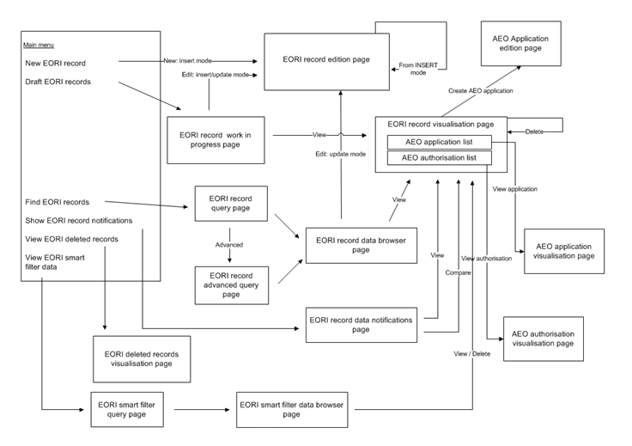
Figure 3. EORI System User Interface and workflow diagram

Recommended objectives

3.1 Background

In accordance with the CEFTA Additional Protocol 5 and its Annexes, the CEFTA Parties agreed to recognise the Authorised Economic Operators’ Programmes in each CEFTA Party, provided that both the legislation and implementation of each local programme is fully in line with the relevant EU acquis.

Authorised Economic Operators (AEO) means an economic operator established in one of the CEFTA Parties, which is deemed reliable in the context of its customs related operations and that, therefore, is entitled to enjoy benefits in one or more CEFTA Parties.

The CEFTA Parties endeavour to provide, in line with the WCO SAFE framework of standards and the relevant EU provisions, the benefits for AEO with regard to safety and security as provided in Articles 9 to 11 of Annex III of the AP 5. It is important to note that with regard to the protection of professional secrecy and personal data the principles of Article 27 of the AP 5 shall apply.

In each CEFTA Party, AOEs shall at least enjoy benefits as specified by Annex III of the AP5.
The status of the AEO shall be granted by each CEFTA Party in line with Annex III of the AP5. Suspension, rejection, revocation and annulment of the status of Authorised Economic Operator shall be done also in accordance with Annex III of the AP5. The status of AEO shall be recognised by other CEFTA Parties on the condition that the implementation of AEO Programmes, are fully in line with Annex III of the AP5. The status of alignment and implementation of each AEO Programme shall be validated in accordance with the CEFTA Decision No 1/2019.
CEFTA Parties shall regularly inform each other of the identities and specifications of their AEOs, for the purposes of security, and include the following information:
- the trader identification;
- the name and address of the AEO;
- the number of the document granting the status of AEO;
- the current status (active, suspended, revoked);
- the periods of changed status;
- the date on which the certificate becomes effective; and
- the authority which issued the certificate.

Detailed technical specifications for Recognition of AEOs Programmes are written on the basis of the WCO GNC Utility Block, which is a global standard of an automated data-exchange system. The Appendix III of the Annex I of AP5 specifies common data sets related to the Recognition of AEO which will be exchanged between CEFTA Parties.

3.2 Legal framework and compliance
- Legal Framework – Additional Protocol 5, Technical Annex and the CEFTA Decision No 1/2019;
- Compliance – the CEFTA Parties must ensure that the AEO information exchanges and all related data comply with the data protection legislation of each Party; that the data remains secured in their respective systems and is synchronised across the IT systems of all involved CEFTA Parties. The availability of the AEO information is specified and measures are defined, in the case where AEO information would not be available for the processing of a Customs notification or Customs declaration.

3.3 Protection of Professional Secrecy and Personal Data
The data exchanged by CEFTA Parties shall enjoy the protection extended to professional secrecy and personal data, as defined in the relevant legislation applicable in the territory of the recipient CEFTA Party.
In particular, this data shall not be transferred to persons other than the competent authorities in the CEFTA Party concerned, nor shall it be used by those authorities for purposes other than those provided for in the AP5.

PART II – CEFTA AEO Database – Technical Specification

Business processes
CEFTA AEO database shall support the following business processes:
- Validation of the status of alignment and implementation of each local AEO Programme
- Submission of relevant data for each holder of an AEOS authorisation
- Granting (authorisation), suspension, rejection, revocation and annulment of the status of Authorised Economic Operator

4.1 Validation procedure

The CEFTA Decision No. 1/2019 establishes the validation procedure for the recognition of CEFTA Parties’ AEOs’ Programmes with regard to the safety and security (AEOS).

The CEFTA Parties endeavour to provide, in line with the WCO SAFE framework of standards and the relevant EU provisions, the benefits for AEO with regard to safety and security as provided in Articles 9 to 11 of Annex III of the AP5. With regard to the protection of professional secrecy and personal data the principles of Article 27 of the AP 5 shall apply.

The Decision stipulates conditions for starting the validation procedure for the recognition, application for starting and initiating the validation procedure, validation mission and subsequent information gathering. In addition, the recognition of the AEOS Programme, procedure after a CEFTA Party’s AEOS Programme has been recognised, including exceptions; and coordination and training activities are defined.

Diagram flow for validation of the status of alignment and implementation of each AEO Programme:

Figure 4. Validation procedure workflow diagram

4.2 Submission of relevant data for each holder of an AEOS authorisation

This section specifies common data sets (listed in alphabetical order) related to the recognition of AEO which will be exchanged between CEFTA Parties:

Table 1: Data fields for the recognition of AEO

Data filed | Definition | Domain values; remarks
Accepted | The status of AEO data record in Result message | Values: 0 = Rejected, 1 = Accepted
AEO certificate status | Code to distinguish between current, suspended and revoked certificates. | Values: C = Current, S = Suspended, R = Revoked
AEO Certificate Type | The type of AEO certificate | Certificate types: To be defined by the partners
AEO TIN* | Unique identifier for the authorised economic operator allocated by the “Granting” partner and linked to the relevant AEO certificate. | “Granted” AEO trader Identification assigned by the “Granting” partner
“ALIAS” TIN | “Alias” TIN assigned by the „Lodgement“ partner to any “Granted” AEO TIN in case the „Lodgement“ partner cannot process the “Granted” AEO TIN assigned by the “Granting” partner. | “Alias” TIN assigned by a „Lodgement“ partner to a “Granted” AEO TIN
City | City name of the AEO | City
Data Requirement Acronyms |  | R = Required, O = Optional
Data Type Acronyms |  | a = Alpha, n = Numeric, d = Date, dt = Date Time
End date | It is the end date of the validity period of the AEO TIN. Together with the Start Date data item, it provides the full picture of the validity that the AEO TIN may have during its lifecycle. | Defines the date at which the AEO certificate status ceases to be applicable.  Together with the Start Date item, it defines the period during which the AEO certificate status is applicable. If the end date is empty the validity period is 'open ended'.
Extraction Type | The type of the extraction performed | Values: F = Full, D = Differential
Full name | Full name of the AEO.
Language Code | Language code identifying the language/character set. | Language Code used to define the language used for all textual information  (ISO Alpha 2 Codification – ISO 639).
Message identification | Unique message identifier | Identifier created using GUID algorithm
Operation | Code to distinguish between created, updated and deleted records. | Values: C = Create, U = Update, D = Delete
Other TIN | Locally defined Identity Number | Used in the cases the partner has Identity Number not compliant with WCO Data Model
Postcode | Postal code of the AEO.
Reference Extraction Type | The type of the extraction performed in Equivalence message | Values: F = Full, D = Differential
Reference Message identification | Unique response message identifier | Unique message identifier using GUID algorithm
Reference Sequence number | Result message number | Identifies the Result message sequence
Status Details | Description of the details of the status | Free text up to 500 characters with status details
Sending date and time | Date when the record is sent | Date and timestamp when the record is sent
Sending organisation | ISO – 3166 alpha 2 code for the partner sending the record.
Sequence number | Identifies data exchanges as result of extraction | If this is a full extraction of data, the sequence number corresponds to the sequence number of the encompassed differential extraction.
Short name | Short name of the AEO. | Short name of the AEO limited to the maximum of 35 characters that are provided for in the WCO data model.
Start date | It is used to define the starting date of the validity period of an AEO TIN.  Together with the End Date item, it provides the full picture of the validity of a particular value that the described item may have during its lifecycle. | Defines the date from which the AEO certificate status is applicable.  Together with the End Date item, it defines the period during which the AEO certificate status is applicable.
Status Code | Codes for specific scenarios | Values: E00001 = Failed to insert, record already exists, E00002 = Failed to update, record does not exist, W00003 = Failed to delete, record does not exist, I10001 = Record updated, but not changes included
Status Type | Identifies the type of status information. | Values: ‘E’ = Error, ‘W’ = Warning, ‘I’ = Information Only
Street and number | Street and number of the AEO.
Trader Local Identifier | Unique identifier for the authorised economic operator allocated by the competent authority and linked to the relevant AEO certificate
Transaction identification | Technical element allowing to group several operations into one atomic transaction
Version | Technical element to indicate the version of the message structure

* WCO Data Model defines AEO TIN as an unique identifier for the authorised economic operator allocated by the “Granting” partner and linked to the relevant AEO certificate. The EORI number (Economic Operator Registration and Identification) comprising: (1) identifier of the economy that issued the TIN, and (2) local unique number is compatible with WCO TIN.

4.3 Granting, suspension, rejection, revocation and annulment diagram flows

Authorisation process is responsibility of the respective CEFTA designated authority, and after the AEO status is granted, that respective authority shall update the CEFTA AEO database. Only authorised economic operators from the Parties with recognized programs will be in the database.

CEFTA designated authorities could be provided with AEO database extension to cover management of the application for AEO status process, and the interface would be implemented according to the existing solution in EU:

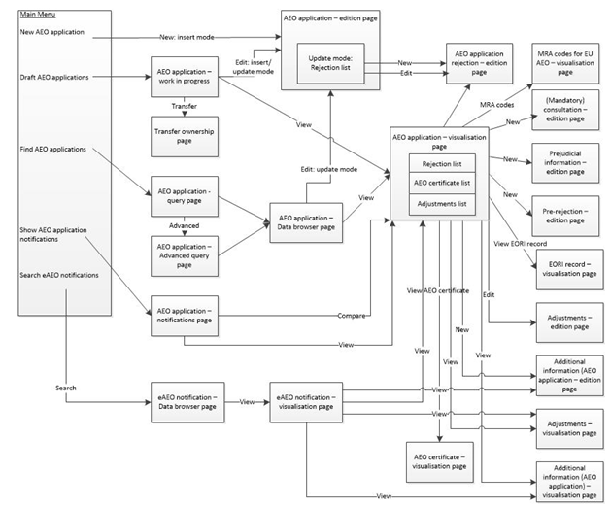
Figure 5. Application for AEO status workflow diagram

The following diagram illustrates suspension, rejection, revocation and annulment of AEO status as implemented in EU:

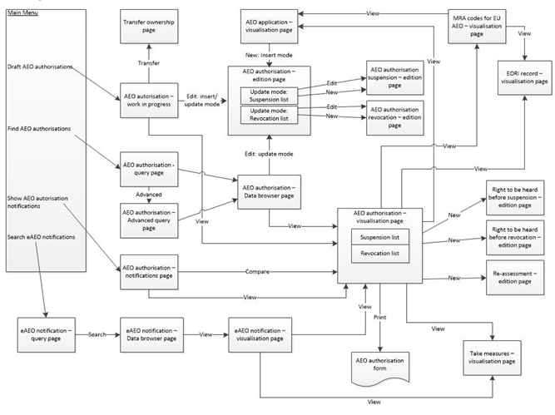
Figure 6. AEO status changes workflow diagram

4.4 Utility Block Executive Summary for the AEO

This section provides a description of the “Globally Networked Customs (GNC) Utility Block (UB) for the AEO Mutual Recognition.” It is built on the UB structure endorsed by the GNC Ad-Hoc Group. The proposed software architecture describes how the status of the AEO could be updated or communicated through software to software interaction, with the CEFTA AEO Database on one side and respective CEFTA Party IT solution.

ENTITIES LAYER
Partner refers to the contracting CEFTA Party (its Customs Administration). It is important to note that every partner will act in two distinct roles:
• “Granting” role: As the “Granting” partner allocating the AEO status to a trader, performing re-assessment and evaluation of this AEO.
• “Lodgement” role: As the “Lodgement” partner processing a notification/declaration lodged in its Customs transaction system by a trader.

Trader refers to the economic operators which play an active supporting role in the information exchange underpinning the AEO process. Two trader roles participate in the AEO process:
• “AEO”: As the trader certified as an AEO by the “Granting” partner;
• “Lodging” trader: As the trader lodging a notification/declaration to the “Lodgement” partner making reference to his AEO status and the AEO status of his partners.

The AEO recognition process choreographs the exchange of information between the partners. The two trader roles are included in order to illustrate the end-to-end process. However, it must be noted that the first pillar only covers Customs-to-Customs interactions.

BUSINESS RULES LAYER
Comprises a number of detailed rules concerning the following:
• Contact points between partners (CEFTA Parties);
• Requirements for:
o the AEO information;
o the trader as one of the supporting participants in the end-to-end business process;
o Customs transaction systems in the “Lodgement” partner;
o the risk analysis systems in the “Lodgement” partner;
o AEO Identity Management and, in particular, the aliasing process by the “Lodgement” partner;
o the nature and frequency of data exchange, monitoring and statistical requirements.

The compliance of all partners of the AEO to the WCO standard regarding the TIN structure is a major simplification opportunity.

DATA CLUSTER LAYER
The AEO relies on the exchange of two functional messages:
• “Granted” AEO information;
• “Alias” TIN between the “Granting” partner and the “Lodgement” partner.

TRIGGER LAYER
The AEO features three variations for choreographing the interactions between the partners according to the following criteria:
• Whether or not there is the need for the “Lodgement” partner to assign an “Alias” TIN (triggered by misaligned structures of the TIN numbers between the partners);
• and in the case of alignment of the TIN structure between the partners, the choice for a “Lodgement” partner to opt for a “Pull” mode (instead of “Push” mode) to access the AEO information from the “Granting” partner.
The three options are:
• “Push” of “Granted” AEO information and “Push” back of “Alias” TIN between the “Granting” partner and the “Lodgement” partner, for those cases that the partners have misaligned TINs;
• “Push” of “Granted” AEO from the “Granting” partner to the “Lodgement” partner when partners have aligned TINs;
• “Pull” of the “Granted” AEO information by “Lodgement” partner from the “Granting” partner, which requires TIN alignment.

INTERFACE
The recognition of the AEO Programs defines the set of four technical messages associated with the following three options in the trigger layer:
• “Granted” AEO information is sent from the “Granting” partner and the “Alias” TIN is returned from the “Lodgement” partner, for those cases that the partners have misaligned TINs;
• When partners have aligned TINs, “Granted” AEO is sent from the “Granting” partner to the “Lodgement” partner;
• “Granted” AEO information is acquired directly by the “Lodgement” partner from the “Granting” partner.
It also provides the technical messages in Extensible Markup Language (XML) schemas and Web Services definition in Web Services Definition Language (WSDL).

INTEGRATION
The integration layer needs to be profiled by each partner whose AEOS programme has been recognised. This includes the business case for local profiling, the use of the AEO information for the risk assessment of notification/declaration, and local provisions for AEO identification. It also sets the requirement for the availability of the exchanged data, provides an indication of the possible data volumes, and the compliance and infrastructure requirements.

COMMUNICATION
The information exchanges take place over the internet. The security of the exchanges is ensured by establishing of Virtual Private Networks (VPN) connections and encryption using security certificates.

IT Processes

5.1 AEO System architecture
Authorised Economic Operator
Database (AEO DB)
Common Domain
Local Domain
External Domain
Economic Operator
Local Application

Fig 1. General structure of Central Economic Operation System (Central EOS System)

Central EOS System is used to encompass the EORI and the AEO systems, ideally to hold and manage in a single repository the data which are common to those systems.

EOS System consists of two subsystems:
- EORI - Economic Operator Registration and Identification;
- AEO - Authorised Economic Operator System.

The EOS application is composed of the following main domains:
- EORI:
  - EORI Record: Allows consulting and managing EORI records;
  - Submitted Application: Allows consulting and managing Submitted Application and the related workflow information (e.g. additional information);
- AEO:
  - AEO Application: Allows consulting and managing AEO applications and the related workflow information (e.g. mandatory consultations);
  - AEO Authorisation: Allows consulting and managing AEO authorisations and the related workflow information (e.g. consultations during re-assessments).

Each of these domains may be accessed from the main page. However, the access to the domains and their management operations depends on the profiles assigned to the user by his local administrator.

EOS System consists of 3 activity domains:
- Common domain – domain that connects administrations;
- Local domain – domain under local control;
- External domain – domain that connects EO applications and Customs Administration IS.

Access to Data
Regarding the availability of or access to data there are at least three categories that the Contractor should consider:
- Data that is collected and used only internally, by representatives of institutions of one CEFTA Party, ("internal data");
- Data that is reported/disseminated to interested circles to which a privileged access has been conceded, e.g. colleagues from other CEFTA Parties (limited to Customs Administrations and competent Authorities involved in the clearance of goods) and the CEFTA Secretariat ("reported data");
- Data that is published via, e.g. the public searches ("visible data").

5.2 Communication with AEO Database (DB)

The CEFTA Secretariat is the central point of reference for the AEO DB. It provides the infrastructure and services for the following tasks (Fig. 2):
- Store the AEO data at the central level;
- Collect the local EO data provided by the CEFTA to the central repository (master copy of the consolidated local information);
- Provide AEO data to the CEFTA systems;
- Consult the Economic Operator Registration and Identification data and its AEO status against the central repository;
- AEO Application allows consulting and managing AEO applications and the related workflow information (e.g. mandatory consultations);
- AEO Authorisation allows consulting and managing AEO authorisations and the related workflow information (e.g. consultations during re-assessments).

Main communication between AOE DB and all others CEFTA economies will be established via WEB Services.
Registrated Users
Designated authorities
(Ministry, Authority, Office )
WEB Services
AEO DB
. . .

. . .
Legal Entities

Others

Fig 2. General structure of communication between designated authorities and the AEO DB

Web Services, through which designated authorities receive Central Economic Operation System information regarding the existence and validity of AEO authorisations, could be for instance:
- Government service (authorisation system);
- Export Control System;
- Import Control System;
- Etc.

In special circumstances Government Layer could be granted rule to access AEO DB directly.

Others can be communicate with AEO DB using the following:
- LDAP – managing user access authorisations;
- System administrators with admin privileges;
- Ministry of Internal Affairs with limited data access;
- Etc.

Entities Layer
The term “partner” refers to the contracting parties that recognised its AEOS recognition programme. AEO recognition process describes the exchange of information between the partners.
Every partner acts in two well defined roles:
- The “Granting” role: as “Granting” partner allocating the AEO status to a trader, performing the re-assessment and evaluation of this status;
- The “Lodgement” role: as the “Lodgement” partner processing a notification/declaration lodged in its Customs transaction system by a trader.
The term “trader” is associated with the economic operators which have an active supporting role in the information exchange supporting the AEO recognition process. Traders participate in the AEO recognition process in two distinct roles:
- “AEO” trader: as the trader who is certified AEO by the “Granting” partner;
- “Lodging” trader: as the trader lodging a notification/declaration to the “Lodgement” partner making reference to his and his partners AEO status.

“Push” and “Pull” modes
The “Push” and “Pull” modes are terms that describe how AEO data is exchanged between partners. Since database access will be based on WEB Services the meaning of these terms are as follows:
- “Pull”:
  - create (POST);
  - update(PUT);
  - delete (DELETE);
- “Push”:
  - read (GET).

Specifically, the “Push” mode denotes the instance where the owner of the information provides a copy to the user, whilst the “Pull” mode denotes the instance where the user of the information requests it from the owner. Sequence Diagrams of “Push” and “Pull” modes are given in Fig. 4, and Fig. 5, respectively.

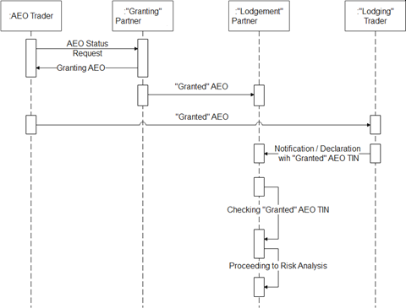
Fig 4. Sequence diagram “Push” mode – “Granted” AEO TIN

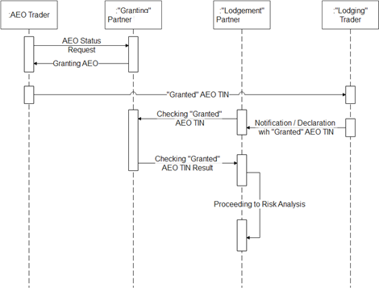
Fig 5. Sequence diagram “Pull” mode – “Granted” AEO TIN
Sequence Diagrams that illustrate technical protocols for “Push” and “Pull” modes are given in Fig. 6, and Fig. 7, respectively.
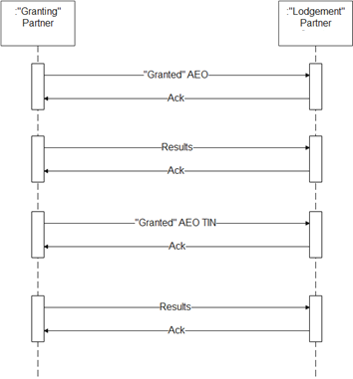
Fig 6. Sequence diagram for technical protocol for “Push” mode

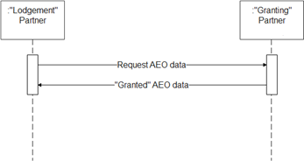
Fig 7. Sequence diagram for technical protocol for “Pull” mode

Business Rules Layer
Business rules layer consists of a number of rules that are concerned with the following:
- Contact points between partners;
  - All partners need to appoint the contact points for technical issues and contact points for business and organizational issues and make their details available to all other partners.
- Requirements for the following:
  - The AEO information;
  - The trader as one of the supporting participants in the end-to-end business process;
  - The customs transaction systems in the “Lodgement” partner;
  - The risk analysis systems in the “Lodgement” partner;
- AEO Identity Management;
- Frequency of data exchange;
- Monitoring and statistical requirements.

Data Cluster Layer
The AEO recognition process relies on the exchange of two functional messages:
- “Granted” AEO information;
- “Alias” TIN between the “Granting” partner and the “Lodgement” partner.

Trigger Layer
The AEO recognition process can be supported by three choreography cases between the involved stakeholders. The choreography cased depends on the following factors:
- The capability of the “Lodgement” partner to process the “Granted” AEO TIN;
- Depending on the former, the choice between the “Pull” and Push” Method.

5.3 Modules supporting the CEFTA AEO database
The following modules are to be developed to support the functioning of the CEFTA AEO Database.

Document Management System:
All documents created by the stakeholders and/or received throughout the procedures will have to be electronically available within the CEFTA AEO database.

Automatic generation of output documents:
Various output documents, in PDF and editable format shall be automatically generated from the CEFTA AEO Databases software.

Search module:
It will enable easy and flexible search throughout the CEFTA Databases, for easier access to relevant information; it should support several search modes, i.e. searching in different fields. Three different search modes shall be implemented:
- Smart search (In this mask the user can enter the query with or without field identifiers)
- Quick search – key dates, numbers, etc.
- Advanced search - allows searching via number of parameters.

Reports:
The system will enable generation of various reports and certificates.

Code lists:
AEO database will contain all relevant code lists with explanation of each value in the list.

Help module:
AEO Database will contain interactive help for easier navigation of end-users through the software.

Data exchange with external databases:
CEFTA Databases should be designed to enable acceptance and extraction of XML or JSON documents.
The Contractor shall develop a mechanism to upload the JSON files via the RESTful web service to the AEO database.

Alerts service:
An alerts service shall be integrated into the software to allow users to track specific notifications. The system will automatically send an e-mail alert when a defined change occurs.

Graphical User Interface (GUI):
The Contractor shall also ensure multilingual Graphical user interface (GUI) for the CEFTA AEO Database and related modules, in all languages of the CEFTA Parties and English. The system shall allow both Latin and Cyrillic characters both in the user interface as well as in the search mode.

Screen #1 /Insert new AEO/
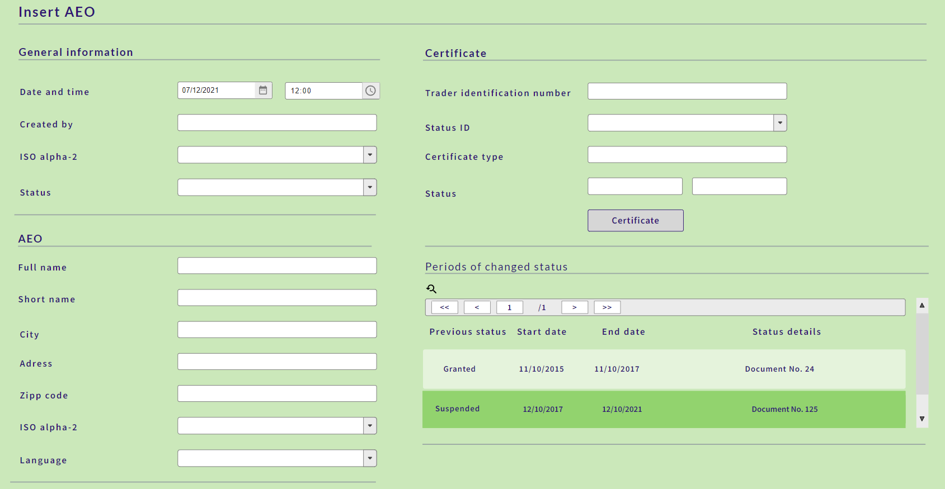

Security Requirements

CEFTA AEO Database requires a high level of data confidentiality, as it will also contain information not publicly available or not yet published. Access control is to be provided depending on the role and responsibility which grants access to data and documents to specifically authorised persons only, while excluding, for example, system or database administrators. All accesses to the system have to be logged for monitoring and non-repudiation purposes.

6.1. Identity Management and Authentication / Authorisation
Both authentication and authorisation for the CEFTA AEO Database shall be based on a central credential store. No personal configuration data shall be stored locally on the workstation. With regard to identity authentication, the system must ensure user authentication to positively identify the client requesting access to the service.
Single sign-on (SSO) allowing an authenticated user to gain access to the CEFTA AEO Database shall be possible without the user being prompted to perform additional logins.
Access to the CEFTA AEO Database shall be secured based on a role based access management of the user identity. Roles shall be used to partition the application's user base into sets of users that share the same security privileges within the application. Users shall be mapped to roles, and if the user is authorized to perform the requested operation, the system must allow the operation.

6.2. Data Confidentiality and Professional Secrecy
The database behind the CEFTA AEO Database have to be protected against leakage as far as technically feasible. In general, the system has to provide strong end-to-end encryption of all data, including the database system and the documents.
The security plan has to ensure that all non-authorised users, including system and database administrators, do not have access to confidential and sensitive data.
The data exchanged by CEFTA Parties shall enjoy the protection extended to professional secrecy as defined in the relevant legislation applicable in the territory of the recipient CEFTA Party.
In particular, this data shall not be transferred to persons other than the competent authorities in the CEFTA Party concerned, nor shall it be used by those authorities for purposes other than those provided for in this Protocol.
The backup strategy must take the confidentiality requirement into account. A disaster would also be the loss of the master key to the database. A recovery must be possible if all users who have the maximum rights are not available anymore.

6.3. Protection of Personal Data
Personal data have to be protected. The data protection has to respect standard data protection guidelines. This means, in particular, to secure data against accidental destruction or loss and against unauthorised access, alteration or dissemination. The circle of persons with authorised access shall be fixed and kept to a strict minimum.

6.4. Access Logging & Monitoring
The CEFTA AEO Database will log: accesses, changes to access rights and changes to the system. The minimum information to be logged by the database contains:
- Access activities
- Maintenance activities
The Contractor must ensure that all log files are off-loaded to the central logging system for monitoring.

6.5. System
Depending on the hardware and software requirements, the CEFTA Secretariat will secure appropriate hosting infrastructure for testing and production environments. Selected Contractor will provide development environment.

6.6. Security Plan
The Security Plan needs to guarantee confidentiality, integrity, availability and accountability across all systems in scope, according to the classification of the data at stake and an analysis of the potential threats and safeguards.

